Logistics Discussion

* Jan 30, Feb 14, 2024 - Adam, Colin, Jason

Currently working on:

* Rig board – job board data alignment
  + Including loaded / on location
  + Auto-Loaded is waiting on work from BPAVS
    - BPAVS integration not planned yet.
* Backhaul functionality
  + Click on rig bin, “Rig Board” page
  + How to show back haul on job board page…..
    - Look at status’ – On location & Returned - #19
* MTS printing online
  + Allowing the printing of the MTS at any point of the process with updated truck/crew info. Reschedule will also update information
  + Need access to MTS
    - Add to product haul list – search by call sheet / load id (need to be able to find) – Next Project
    - Add to call sheet in eService – Next Project
    - Need to have latest version – Trigger: Loaded to bulker – Next Project
    - Print from Bulk Plant Board
  + Add timestamp to the footer – In Progress
* UAT testing available Feb 12, 2024

Summary of Requirements:

1. Put logistics functionality in a single location
   1. Currently working on Rig board, Bulk Plant, Crew Mgmt & Job Board

Solution: Standardize current functions as API

* + 1. Add some functions to Job Board
    2. Add some functions in BPAVS

Put off until we have a decision on Bulker centric or Driver centric. We will need to understand the logistics guys’ mindset, otherwise a universal UI can be provided with everything entered.

1. Simplify Bulk Plant Page
   1. Solution: Add MTS and Blend Request pages. Bulk Plant Page UI may be redesigned as a dashboard like logistics Excel Silo tracker.
2. Change NW (Norman Wells) to NWT
3. Haul Blend call sheets available & rules
   1. Solution:
      1. Dry Blend signature generation from blend recipe. This will help to compare two blends regardless of the order of additives.
      2. Easy to match blend in any case.
      3. Haul Blend update to link the correct call sheet.
4. More room for notes on the Job Board -DRB
5. Rig bin to Rig bin (from 1 location to another)
   1. Solution:
      1. Haul from rig bin to rig bin can be done in upcoming release. It follows current crew status.
      2. We will need to build a new status flow to accommodate this. An extensive solution is needed.
6. Raw Product - Vendor to BP – UI different, logic Same as 6
7. Raw Product - BP to BP – UI different, logic Same as 6
8. Off duty timer – fix – DRB fix to handle failure response from API
9. Bin Flush – part of BPAVS
10. Job Board Planned Units – separate today and tomorrow – DRB
11. Add Expected Time on Location to Job Board – DRB
12. Evercrete – move through the system – Add a button to move to BlendCompleted status out of BPAVS. However, is it a workaround. We need to understand more to give a solution.
13. Project loads – truck movement and cement tonnages – The Haul Blend function can satisfy most of these needs, the individual UI may be needed for each specific scenario.
14. Tracking cement on pad locations – Pop us history window
15. Repurposing/reblending Cement – Blend Library update
16. Chem Vans – simple tracking of movement – Simple tweak to allow it happen if no special requirement for UI.
17. Visibility of spare units in the district - DRB
18. Backhaul – show on job board – No Back Haul concept in future, just Haul From/To, it will show up in upcoming release.
19. Future Desires:

* Would like to do most of the functionality in a single place – Job board is the preference
* Feeling like we are bouncing around to different pages to do different items.
  + Makes it feel complicated

1. Bulk plant page

* Would like this page to be reworked. It is too busy and complicated
* Do not need to see the scheduled blends
* Do not want to move blends to the bin – do this automatically
* Once a blend is completed please move it to the bin
  + Have some logic to make sure that the bin is empty
  + If product is in there, stop the process and deal with product in the bin
* **Current Bulk Plant Page - GP:**

* + **Desired Bulk Plant Page - GP:**

* This is Colin’s desire, but it loses the view of conflicts if exists. E.g. there was 0:1:0 ‘G’ left in the bin from previous request. We are going to load ECOPrime from the next request, we want to avoid over topping by mistake. We will need to show what is currently in the bin and what is going to be loaded.
  + **Can the view be of just the bin**
  + **Have a calendar icon (or other icon) to have a popup showing upcoming scheduled blends**
* When we provide API for BPAVS, it will stop BPAVS loading to a bin if a different blend is in the Bin.

I would propose as following.

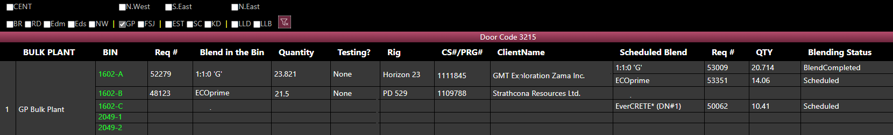

* + Only show completed blends and have them put into the bin right away
    - Continue to show all the associated information for the blend in the bin
  + I think you guys captured my feedback and requirements pretty well. I see there is still some concern about scheduled blends. Again, I do not see this as an issue: we can treat this the same ways as bins on location. We should get an error message if trying to add one blend to a different blend. I see no need for scheduled blends anywhere.
  + On mock up “Desired Bulk Plant Page – GP” I notice that there are still 2 call sheets/rigs/clients assigned to 1602-A. If this is because the product in there is the same blend but used for both rigs (ie 10 tonne blended for GMT and 13.821 blended for Birchliff, or 10 tonne blended for GMT and 13.821 backhauled from Birchcliff) then this is OK, in fact it is ideal. Or is there some other reason why there are 2 call sheets listed?

1. NW is Norman Wells. This commonly mistaken for N. West.
   * Would like to change NW to NWT to make sure that these are not mixed up
2. Haul Blend – options for different call sheet…

* Currently call sheets are available that match the base blend
  + Concerns that this could cause an error if people are not paying attention and select only the first call sheet in the list
  + View above will keep call sheet #’s visible
* If call sheet which the blend request was originated is not complete, keep the same call sheet.
* If call sheet is complete, manually enter
  + Have validation on exact blend match (blend + dry blended additives)
* I like the solution you came up with for call sheet numbers, this rule makes sense to me
* Priority here is to help the cement blend move through the Haul process with the added step of being stored and tested prior to hauling.
  + “Count” the load in BI-87
  + Future considerations for this is how it ties into the complexity matrix workflow.
  + Need discussion on the matrix workflow ….. hauling was independent of the workflow – discussed that we may haul prior to having approval, approval is for job execution.

Blend can be hauled any time. Blend Request Id is carried along the hauling process, approval will be against blend request, we always can query the approval status. E.g. show approval status icon on RigBoard.

1. Notes (DRB - Bulker Job Board)

* Need larger area for more notes
* Currently Use Notes for:
  + Non rig haul
  + Raw product
  + Convoy only – notes about the driver or truck
  + Resting
  + Resetting
  + Save for another job
  + Current workaround for convoy only driver, or any notes that need to “stick with” a person or unit is to go to the Resource Board and enter the notes that way. Lots of scrolling and time consuming.
  + These notes are only visible if we “expand” the crew on the job board (things can get missed easily)
  + Need to find a way to identify convoy only drivers
  + Once “non-rig haul”, raw product, etc use cases are complete we wont need to put these in the notes.
  + Biggest issue is planning notes: which hotel is the crew staying at, any special instructions for the next shift, etc.
  + Here is a starting point:

* + Would like the notes specific to the people or equipment to show up in this area as well
  + Other items to do
    - Can also use short name for company
    - Remove (Day) from the data – show date only
    - Shrink Status and dropdown (smaller font if needed)
    - Hide 3rd haul, or other options
  + This will create even more space

1. Rig Bin to Rig Bin
2. Raw product haul

* Vendor to BP
* BP to BP
* Want 2 options with clean view
  + Right click on bulk plant
    - Time
    - Vendor
    - Product – Colin will provide product list to see how we can filter
    - Crew
    - PO
    - Other
* Do we need to go to the bulk plant tab for this? (just thinking about minimizing page changes)
* Is the PO required? Is this being considered for future integration with AX? Or just as a unique trip identifier?
* How will the trips be tracked in BI-087 (will there be a load ID?)
* Right click on Bulk Plant on the Bulk Plant page:

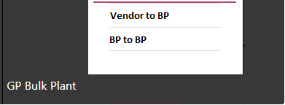

* When clicking on “Vendor to BP”

* BP to BP

1. Off duty timer not working when a haul is pending
   1. It should be integration issue. In latest version of DRB, DRB only sends status change request to eServiceOnline, eServiceOnline side may not reset the timer properly.
2. **Bin Flush**
   1. **How to properly deal with this**
   2. **Who does this? Is this BPAVS only?**

Bin Flush – I think this should be managed in BPAVS, it will NOT be requested from the dispatcher through the DRB.

1. Planned Units:
   1. I noticed today on the job board that there were some duplicate units. Michael Raymond on unit 870011 is one example, though there are a few on here. I have been trying to be on my team to make sure ONLY units that we are using are planned and to unplan any units that we aren’t using (if we change crew, unit, etc).
   2. A screenshot of a computer

      Description automatically generated
   3. Alex pointed out that the managers in RD had put it in the schedule this way, and that the Bulker schedule page was correct but the crew planned for tomorrow was showing up today as planned. As you can see below, Mike and Evan are planned on the truck together today, then Mike is solo for the weekend, then Evan is back on Monday. So everything is done correctly on the district and Logistics side, but the Truck board is showing the unit in duplicate.

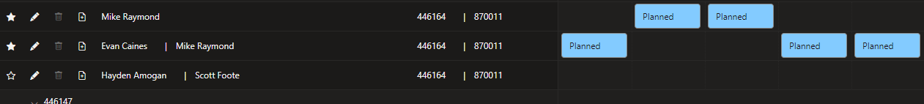

* 1. This is troublesome for a couple reasons:
     1. If we are trying to audit the dispatchers for compliance in using the tool properly, it is frustrating because sometimes it could be that we have duplicate units scheduled, and sometimes it could be just that tomorrow’s unit is showing up.
     2. Having a bunch of unusable units on the page makes things too busy, we don’t know which one to use without bouncing back and forth between pages.
* Potential solutions
* Identify if a unit is planned for tomorrow
* Have the units show up in a different section if they are planned for tomorrow or a different day.
* Don’t have the units show up at all, unit the day they are planned.
  + - **The job board has a 48 hr view which could have the same unit on the board 2 times if one is scheduled for today and one for tomorrow.**
    - **Is there a way to differentiate the units planned for today vs tomorrow?**
      * **Have today’s units at the top, tomorrow at the bottom. If they are the same they stay at the top.**
      * **Have different shading of background color to differentiate between today and tomorrow**
        + **Units at the top for today or today and tomorrow will be dark**
        + **Units at the bottom for tomorrow to be a “dark grey” shading. Just enough to be different from the black background.**

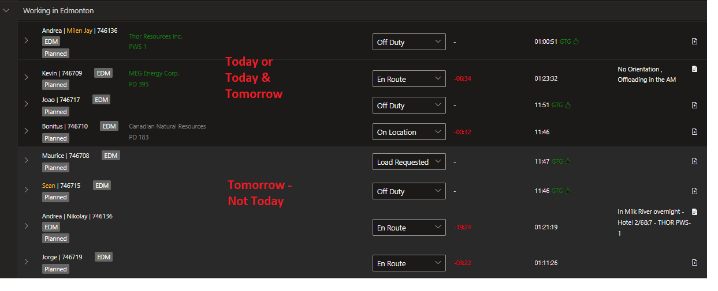

* Duplicate Planned units Units
  + Plan to have “tomorrow’s” units at the bottom with a different shading is sufficient.
  + That was we can send the blend request the night before. This is a good solution.

1. Add Expected time on location to Job Board

* I still need to dig into this a bit more. I would expect that Estimated loading time is important until status changes to “loaded” and then expected on location time becomes relevant.
  + Expected on location time might change based on expected load time. For example if we plan on loading Andrea at 08:00 and her expected on location time is 12:00, but then something at the bulk plant causes her not to be loaded until 13:00, then expected on location time would be 17:00.
* For the hauls, which time dictates the schedule? – Expected On Location Time
* A screenshot of a computer

  Description automatically generated
* When looking at the “On Location” what time is in the window?
* 
  + The first time is Expected Load time
  + The second time is expected on location time
* Is there another place where the time can be put so that it is seen?
  + Team is putting the first load as first best guess
  + Then the 2nd they are putting out 10+ hrs, but often this is still messing with the time of the first one and changing the order creating more work.
  + If they could easily see the time they will keep things straight
  + They don’t feel that this time is important and view it really as 1st, 2nd, 3rd etc
  + DRB - On the Job Board,
    - Change the company name to “Short Name” (Create more space)
    - Add Expected location time so that it is immediately known

* Need to confirm with logistics what time they feel is more important - Expected location time

eService online: Expected on location validation when a crew is selected.

* Go with crew and delay will need to update the time on the job board

eService online : Product Haul Expect on location time synced with putting off Job

1. Evercrete doesn’t go through BPAVS

* Need a different way to deal with this so it can be tracked
* Ever Crete doesn’t go through BPAVS
* We need to either have BPAVS program alternative blending rules for certain blends
* To assign a load to something blended outside of BPAVS, we may treat the same as projects (see below)
* Not sure what the last note means?
* How do we get this blend to move through the bulk plant page as it never gets to a blended stage and then sits and stays on the bulk plant page making it messy

1. Project Loads

* Currently, we can haul cement TOO a project (or remote bulk plant such as Kindersley)
* Need to iron out the process to haul FROM project to a rig
  + Can we generate MTS without having the bulk plant as a middleman – Yes, the product haul concept is changing from Bulk Plant/Rig to Origin/Destination.
  + Can we assign the haul to a current call sheet instead of having to fill out the long form Schedule product haul? – Yes, each MTS can be linked to a call sheet if not created from call sheet directly
* Option on rig to haul from project/storage? – Yes. Haul Blend function is available on project/storage when it is shown on Bulk Plant Board. Or we will make Back Haul consistent across the boards.
* Currently the crew just pulls the load out of storage, logistics has very little to do with this, and so we want to make sure it is super simple. – Does operation dispatch need to schedule a total amount of blend need to be hauled to a job? We will need to track the remains in project storage any way to schedule more blend to be blended and hauled to project storage.
* Crew might load a full truck, and then use for multiple jobs. – It is supported by product haul feature, multiple MTS slips will be created.
* For the job board, can we identify if units are in the projects? Almost like a separate district or how we specify project rigs on the rig board. (NOTE: the project rig function is not being used this year, I need to find out from Brett why not)

On Job Board, we will need to add more information in each haul section which discussed in No. 12.

On Rig Board, we can show project rigs. Refer to KD Bulk Plant on both Rig Board and Bulk Plant Board

1. Tracking cement on pad locations (SAGD, batch surfaces)

* Will need to review the current sheets with you guys to make sure we are meeting all requirements
* Currently there is a low level of trust in how this function works
* BI cement tracking?
  + Cement remaining, loads in and out. How to track and keep real time – BI may not work properly
  + Compare to NE truck board

We have all in-out data for bulk plant/project storage. We don’t have rig bin out data.

Cement remaining can be found on RigBoard. Real time tracking can be a pop up window to show in and out.

1. Repurposing/reblending Cement
   * How to we take a stored cement blend and adjust it
   * This could be as simple as adding one additive, “blending down” or topping up.

Blend library needs to be updated to handle this. After reblending, the recipe will need to show as [Base Blend] + {Additives}, the added additive percentages need to be consolidated.

Process wise, the bad blend must be stored in storage carried over original recipe.

1. Chem Vans
   * This is now the only unit type that is not scheduled through the DRB
   * Simple tracking is all we need, may tie into Supply Chain ordering app?

We can use updated product haul process to handle this if we add it to bulker list. It is more like Vendor to BP as Supply Chain ordering app is mentioned.

1. Visibility of spare units in the district
   * Want to see all the spare unites in a district on the job board
   1. Show trucks with just tractor | trailer
   2. All “available” units
      1. Do not show units that are down

Past Requirements – most are completed or under construction

Some of the items below are from Ops and/or logistics

1. DRB -  bulker crew scheduling
   1. Product Haul ordering
   2. Bulker crew status sync
   3. Per product haul loading/on location sync
2. Cement Quarantine.  Separation of product haul and blend request.
   1. Bulk Plant and vessel master data
   2. Schedule Blend Request
   3. Haul Blend
3. Overtopping prevention
   1. Empty Bin (Bulk Plant/Rig)
   2. Bin content validation (Bulk/Rig)
   3. Blend naming convention
      1. Additive functions
   4. Blend status tracking
4. Cement tracking
   1. Load to Bulk Plant Bin
   2. Load to Rig Bin
   3. Call sheet association with shipping
   4. Post Job integration
5. Movement Journal Integration
   1. BPAVS integration – blending data post back
6. Overflow Prevention
   1. Storage vessel capacity master data
   2. Bulk density calculation
7. Lab DB integration
   1. BPAVS Sampling Integration
   2. Testing status tracking and integration
8. Logistics desires
   1. Back Haul
   2. Blend Transfer
   3. Raw Product Haul
      1. Vendor to BP
      2. BP to BP
   4. Bin Flush
   5. Haul From Project Bulk Plant to Rig
   6. Haul to Project
9. BPAVS integration
   1. Blend Request API
   2. Reblending
      1. Blend Library upgrade
10. Job - material cost
    1. Cement consumption tracking – post job integration
11. Job readiness
    1. Product Haul status tracking
    2. Print MTS on Server
    3. MTS auto-attach to call sheet.